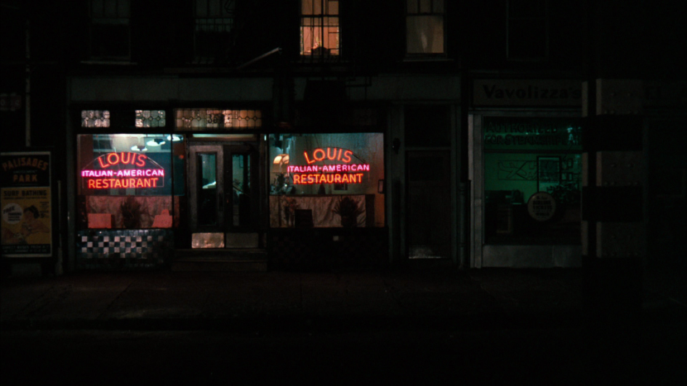

Where in Raleigh, NC Should I Open an Italian Restaurant?

Scott Josephson | Applied Data Science Capstone | 1/2/19

# Introduction

My friend is looking to move out from New York City as he gets closer to retirement. . He has been in the restaurant business for 20 years and has owned several Italian Restaurants in New York. He wants to move to a quieter town, but he still needs income. He has asked me to research other cities to see which towns are need of a good Italian restaurant. I am currently looking at Raleigh North Carolina. I decided to research Italian restaurant competitors, Cafes, Shopping, and Nightlife. I am most interested in finding places from the different categories and seeing where in Raleigh are the greatest concentration of other Italian Restaurants located.

# Data

The data that will be using are from Italian Restaurant Venues, Cafes, Shopping, and the Nightlife in the city of Raleigh. We will utilize the data from Foursquare. We will look at features such as name, categories, address, cross street, latitude, longitude.